

Swarmed Parallel Interpreter for Numerical Analysis with Collaborating Hubs
User Interface Team
CSE 784 – Software Studio
Design Document
version 1.0
2nd November, 2009

By:
Abhay Ketkar
Arun Kumar Kyasaralli
Prateek Jain
Rutu Pandya
Contents

1. Package Diagram 3
2. Classes and Responsibilities 4
2.1 Class Connection 4
2.2 Class Chat 5
2.3 Class ErrorModule 5
2.4 Class ProgConf 5
2.5 Class ProgWin 7
3. Team Issues 9
4. Team Status 10

Package Diagram

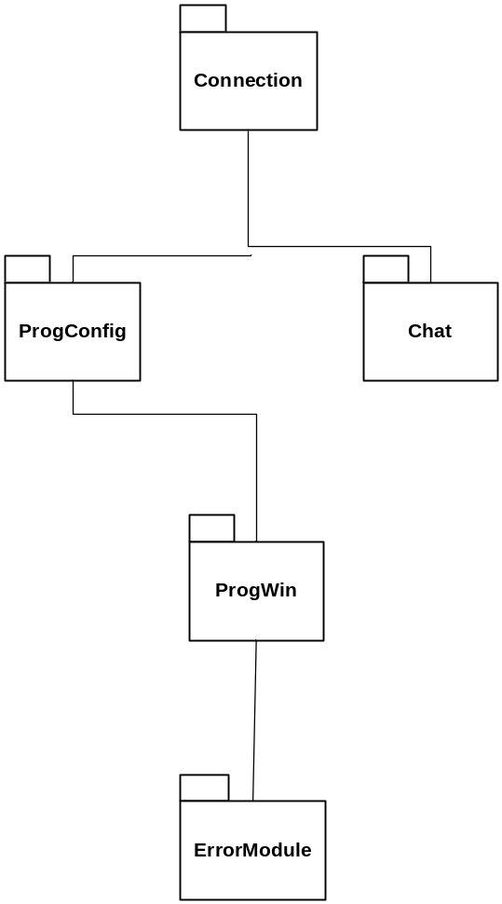

Classes and Responsibilities

Class Connection

Responsibilities: This class is responsible for the connection of a user to the swarm, and to other computers in the swarm.

Function: SwarmConnection(SelfIP, SelfPort, Username, PeerIP, PeerPort);
Returns: List of users in the swarm
Description: This function will be provided by Swarm. If PeerIP and PeerPort are 0 then the user wants to create a new swarm. Else connect to the machine with IP=PeerIP and Port=PeerPort.

Function: msgSwarm(string);
Returns: Connection successful or error message
Description: This function will be provided by connection class. The swarm will just call this function and provide the connection status.

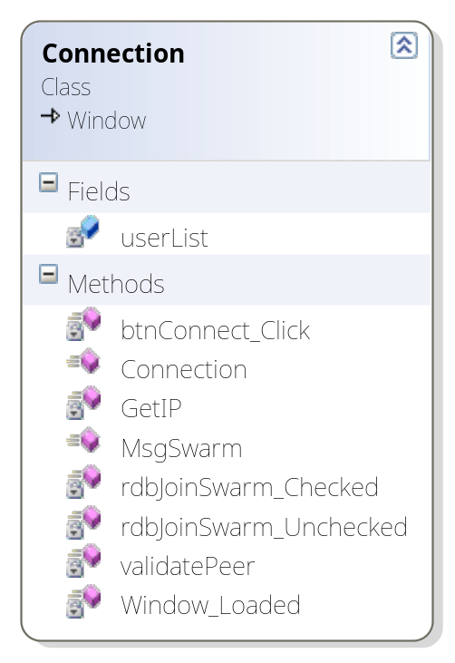

Class Chat

Responsibilities: This class supports the chat mechanism for the SPINACH. The chat messages are broadcasted to everyone in the swarm.

Function: SendChat(Msg);
Description: This function will be provided by Swarm. Chat class will call this function to send message to users in the swarm.

Function: ReceiveChat(string);
Description: This function will be provided by chat class. The swarm will just call this function whenever they receive any message.

Class ErrorModule

Responsibilities: The ErrorModule class is responsible for all the error management in the SPINACH. The mechanism used for error control is as follows:
Each Module would have a set error description and a code associated. The UI maintains a table of these errors, and the error description is looked up from the table, and displayed to the user.

Function: ErrorCode(int number);
Description: This function will be provided by ErrorModule class. Display error to user depending on the error code.

Class ProgConf

Responsibilities: This class is responsible for the main Program Configuration, like loading a program, creating a new program, and displaying a list of users in the swarm, which is constantly refreshed.

Function: NewAccessPermissions(int read, int write, string text);
Description: This function will be provided by ProgConf class. The swarm will call this function in this event with read and write permissions as integer bits. The program text will be also be sent.

Function: error(int errorCode);
Description: This function will be provided by ProgConf class. The swarm will just call this function and provide the error code.

Function: updateList(List<string> userList);
Description: This function will be provided by ProgConf class. The swarm will just call this function and provide the updated list of users.

All the functions above will be registered to the events given by the swarm team.

Function: setUserList(List<string> userList);
Description: This function will be provided by ProgConf class. This function will set the user list provided by the connection class.

Function: setUsername(string user);
Description: This function will be provided by ProgConf class. This function will set the username provided by the connection class.

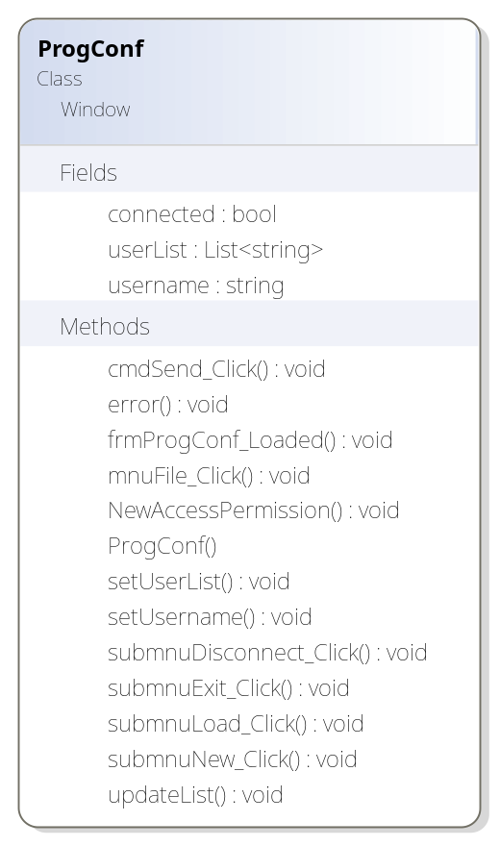

Class ProgWin

Responsibilities: ProgWin is the class that holds program segment, results and plot image of the program. Appropriate functions are provided by this class for editing the program. Some of the important functions include

Function: getUserList()
Descriptions: This function will be provided by ProgWin Class. This function will get the list of collaborators in swarm.

Function: alterUser(string user, string Operation, string permissions)
Description: This function will be provided by ProgWin Class. This function is used to add, edit or delete permissions of user.

Function: editLine(int operation, int linenum, string message)
Description: This function will be provided by ProgWin Class. This function will be called to notify swarm about changes in the program. Swarm then notifies these changes to collaborated users.

Function : string getMessage()
Description: This function will be provided by ProgWin Class. This function is used to fetch messages from swarm.

Function: lockCollaborators()
Description: This function will be provided by ProgWin Class. This function notifies the swarm to lock the program on all collaborator machines. This will be called when one of the collaborator starts the program.

Function: saveProgram()
Description: This function will be provided by ProgWin Class. This function is used to save program text to file system.

Function: savePlot()
Description: This function will be provided by ProgWin Class. This is used to save the plot image to file system.

Function: publishResults(string res)
Description: This function will be provided by ProgWin Class. This is used by core to display results in the result section of the program window.

Function: setImage(ref Object res)
Description: This function will be provided by ProgWin Class. This is used by plot to set the reference to image.

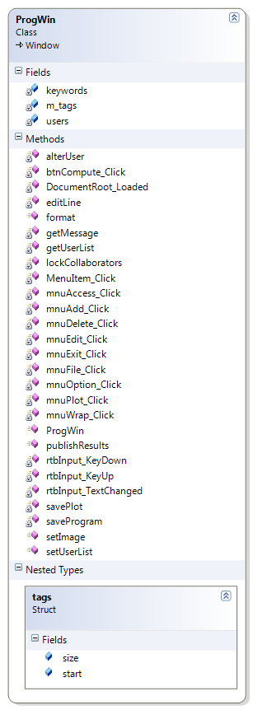

Team Issues

The progress of our team is so far fairly good, we have been able to successfully meet deadlines, and satisfy the requirements as per the schedule. There are a few challenges we face, which are:

- Implementing the requirement for collaborating with all the users in the swarm, instant changes being reflected on everyone’s screens, and providing a distinct color per collaborator. There is going to be network delays, which need to be handled. Issues such as, two users editing the same line of text box and locking the program editing if a user has started the execution need to be addressed.

- The User Interface depends on the Swarm, Plotting, Interpreter Core and Interpreter Front End Modules. These modules need to provide us an error code/number and its description, so every time an error is encountered during execution, the UI can look up the description of the error code/number, and display it to the user. This information is yet to be received from the other Teams.

- Also, due to the dependency of the UI on these other Modules, we have to decide on exact function calls and the events generated. We have decided on almost most of them, but their signature might change.

Team Status

The User Interface for the SPINACH needs to support the complete functionality of the system, right from connecting to the swarm, to executing the program, and displaying results and plots.
The B-Level Specification was the first task we completed, which included the Data Flow Diagrams, and the requirements. Later, after discussing with the Architect and the other teams, there were some changes to be made, which were updated in the B-Spec version 1.1.
A prototype for the UI has been developed, which gives us an idea of the flow of control of the System. It shows a demo of connection, program loading, chatting and program editing.
Working towards Thursday’s integration optional line number feature has been implemented.
This document presents all the classes to be used for UI, and the interfaces exposed to other teams.

